**OpenAI Account Guide**

*Last Modified by: Federico Arroyo*

This guide provides step-by-step instructions for accessing the OpenAI API portal and creating an API key. By following this guide, you will learn how to:

1. Create an account or log into an OpenAI account.
2. Navigate to the API key section on the OpenAI platform and create an API key.
3. Add billing details just in case you go over the free trial (We should stay within the free trial limit at most there is a $5.00 limit).

This API key is essential for connecting to OpenAI's services and using their AI models within your own applications or projects. Proper API key management tips are also included to ensure security and safe handling.

Section 1 - Create an account or Log into OpenAI

Steps:

1. Navigate to [OpenAI API Platform](https://platform.openai.com/docs/overview) within your browser where you will be taken to a login and sign-up page.
2. 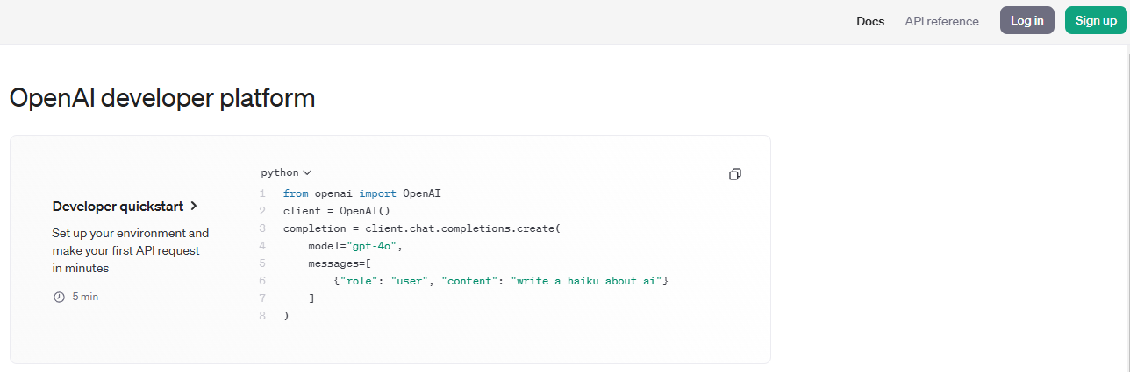
3. Login with your preferred method using email address, or sign-up for a new account.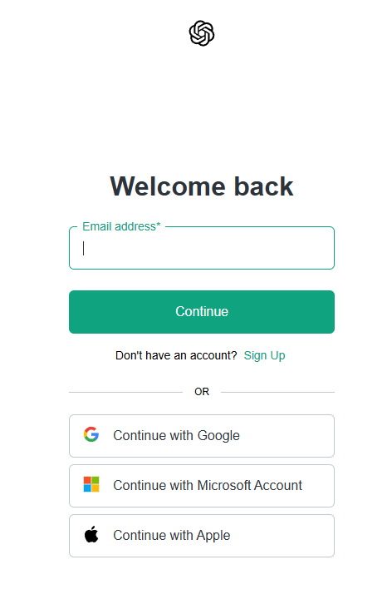

**Section 2 - Create a new project and generate a new key**

Steps:

1. Navigate to the project dropdown and create a new project.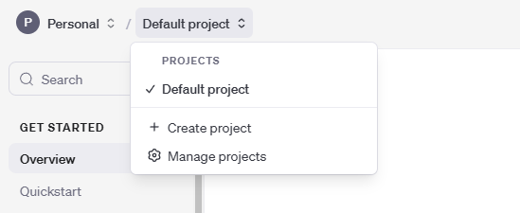
2. Create a new project calling it “caltech-gen-ai-proj”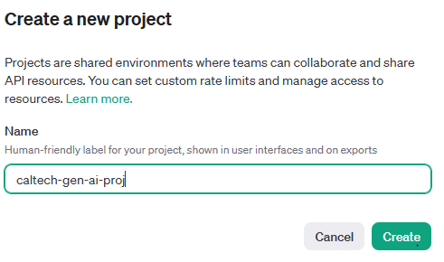
3. After creation click on the “Manage projects” section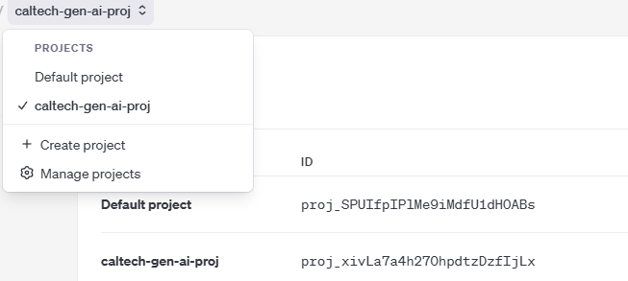
4. On the bottom left hand side bar click on “API keys” to start the key generation process.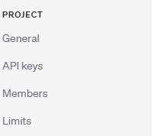
5. Create your new API Key for the given project and save it in a secure location. 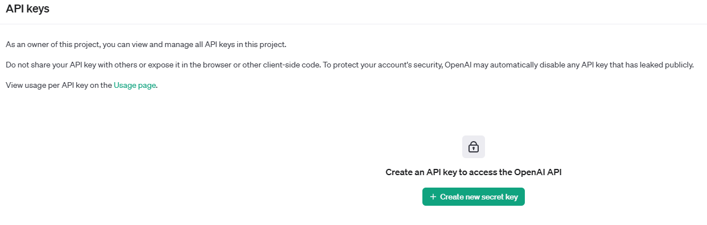
6. Create a new key calling it caltech-test-key: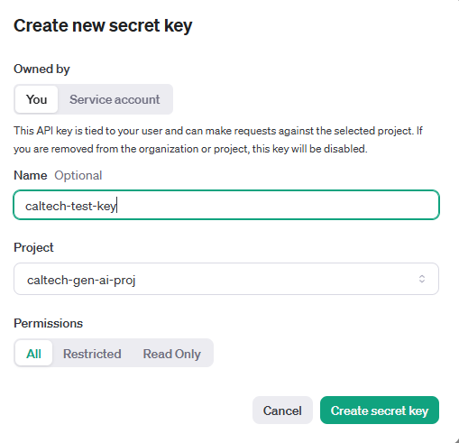
7. Remember to save your key in a secure location as you will not be able to view it again.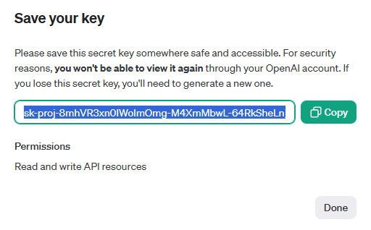

**Section 3 - Billing and Account Payments**

1. Navigate to “Billing” on the right hand side bar of the OpenAI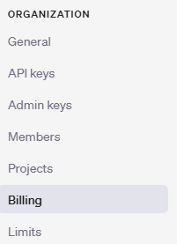
2. Click on “Add payment details” which will bring up a text box and click individual as an option, and add card details.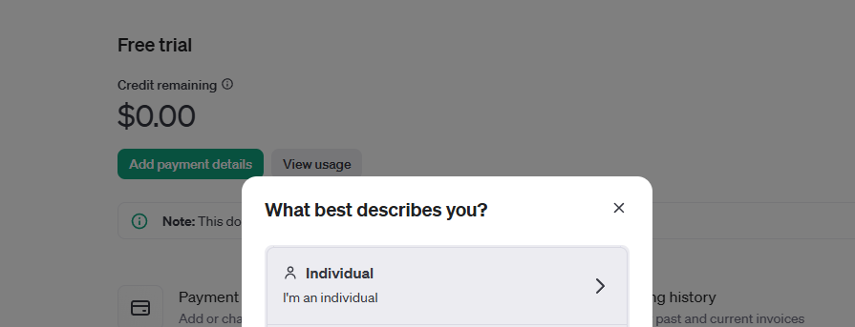
3. Add payment details and you’re all set to go!